Title
Author 1¹, Author 2²
¹ Affiliation, email@univ.com
² Affiliation, email@univ.com

ABSTRACT 8-15 lines using the "Abstract" style, with single spacing.
Keywords list of 3–5 keywords separated by commas
I. INTRODUCTION
The file must be in MS Word format using the dedicated template. Figures and tables must be embedded in the document and not provided separately. The desired length of the article is between 6 and 10 pages. The article is requested in French, but exceptions are possible for non-French-speaking authors. For paragraph text, use the "Paragraph" style (Palatino Linotype, 10).
II. FORMAT
A. Lists and equations
Bullet lists must follow this format:
- First item
- Second item
- And so on

Numbered lists use this format:
1. First item
2. Second item
3. And so on

Equations and formulas must use an equation editor and be numbered consecutively with numbers in parentheses on the right side of the page. They must also be separated from the text by a space.
B. Tables and figures
All tables must be numbered and include a caption. Titles must be placed above the tables. Leave a space below the table. See Table 1 as an example.
TABLE 1. Example
Example | Column A | Column B
Row A | 1 | 1
Row B | 2 | 2
Row C | 3 | 3

All figures must be numbered (1, 2, 3, …) and include a caption. Please ensure they have a minimum resolution of 300 DPI. The figure number and caption must be placed below the illustration. Leave a space below the figure. See Fig. 1 as an example.
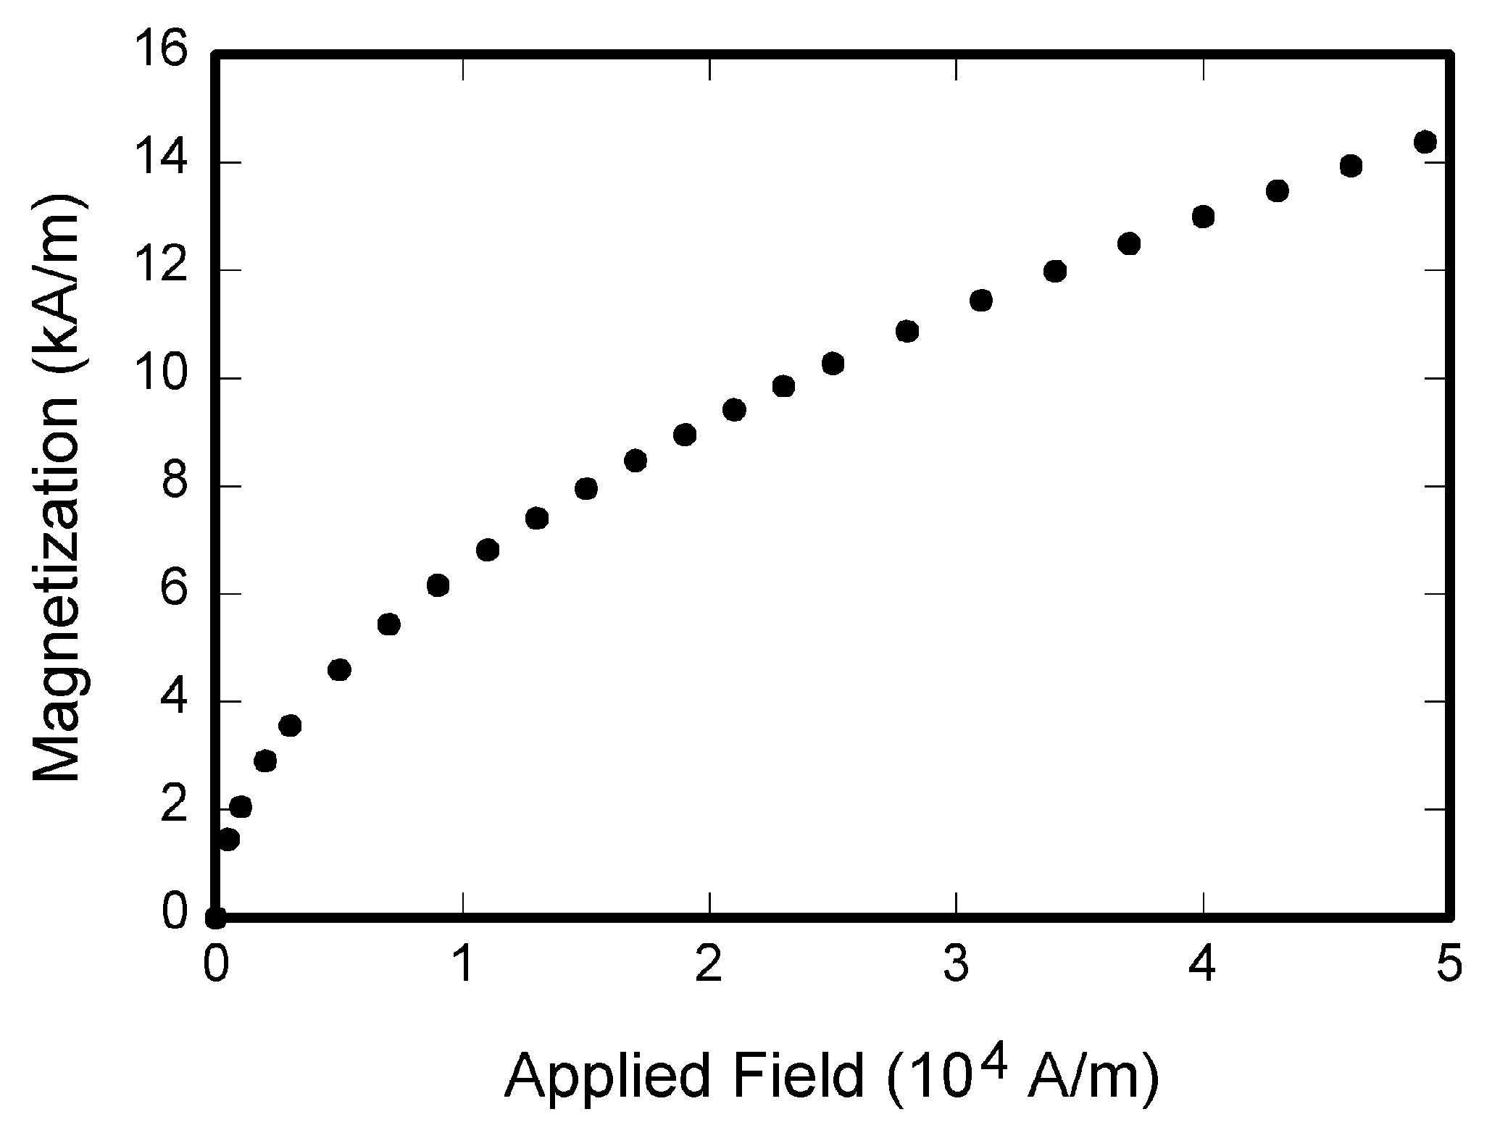
FIGURE 1. Example
 Please avoid any automatic numbering (or cross-referencing).
Please follow the following format for the file name: "JFMS-2025_FirstAuthorName.docx".
REFERENCES
Use the style “Elsevier – Harvard (with titles)”. Please find some examples below.
J. Hamari, J. Koivisto, & H. Sarsa. (2014). Does Gamification Work? -- A Literature Review of Empirical Studies on Gamification. 47th Hawaii International Conference on System Sciences, 3025‑3034. https://doi.org/10.1109/HICSS.2014.377
Taillandier, F., & Adam, C. (2018). Games Ready to Use: A Serious Game for Teaching Natural Risk Management. Simulation & Gaming, 49(4), 441‑470. https://doi.org/10.1177/1046878118770217

